**System Analysis & Design Project:** Blood Donation Management System

By Ahsanur Rahman

**Table of Contents**

Introduction 5

Objective 5

Key Features 5

Scenario Writing 6

Scenario-1: User Registration 6

Scenario-2: User login 7

Scenario-3: Add Profile 7

Scenario 4: Update Profile 7

Scenario 5: Searching for Blood 7

Scenario 6: Contact 8

Scenario 7: Logout 8

Stakeholder 8

User Profile 9

Case Description-01: System Administrator 9

Case Description-02: Blood Donor 9

Case Description-03: Blood Recipient 10

Scope 10

1.User Registration and Login: 10

2.Profile Management: 11

3.Searching Blood: 11

4.Blood Request: 11

5.Select Location: 11

6.Donation History and Tracking: 11

7.Notifications: 12

8.Helpline and Support: 12

Feasibility Study 12

1.Technical Feasibility: 12

2.Operational Feasibility: 12

3.Economic Feasibility: 12

4.Scheduling Feasibility: 13

Project Block Diagram 14

Block Diagram-1: Donor 14

Block Diagram-2: Recipient 16

Block Diagram-3: System Administrator 17

Software Requirement Specification 18

SRS 18

Use Case 20

User Case Description 21

Case Description-01: Registration 21

Case Description-02: Login 22

Case Description-03: Add Profile 23

Case Description-04: Update Profile 24

Case Description-05: Searching Donor 25

Case Description-06: Select Area 26

Case Description-07: Request Blood 28

Case Description-08: Review Donor 28

Case Description-09: Contact Donor 29

Case Description-10: Forget Password 30

Case Description-11: Logout 31

System Design 34

Data Flow Diagram 34

Data Flow Diagram Level-0: 34

Data Flow Diagram Level-1: 35

Activity Diagram 37

Activity Diagram-1: Registration 37

Activity Diagram-2: Login 38

Activity Diagram-3: Add Profile 39

Activity Diagram-4: Update Profile 40

Activity Diagram-5: Searching Blood 42

Activity Diagram-6: Contact Donor 43

Activity Diagram-7: Logout 44

State Diagram 45

State Diagram-1: Registration 45

State Diagram-2: Login 46

State Diagram-3: Add Profile 47

State Diagram-4: Update Profile 48

State Diagram-5: Searching Blood 49

State Diagram-6: Contact Donor 50

State Diagram-7: Logout 51

Sequence Diagram 52

Sequence Diagram-1: Registration 52

Sequence Diagram-2: Login 53

Sequence Diagram-3: Add Profile 54

Sequence Diagram-4: Update Profile 55

Sequence Diagram-5: Searching Donor 56

Sequence Diagram-6: Contact Donor 57

Sequence Diagram-7: Logout 58

Class Diagram 59

ER Diagram 60

# **Introduction**

There are many challenges in managing blood donations that affect both the donor and the blood recipient. In emergencies needs, it can be very difficult for blood recipients to get the exact blood group. Recipients struggle with matching donors due to a lack of real-time data. Through this we bring blood donors and blood recipients together. Through which the desired blood group can be found in fastest time. All the information of the blood donor and blood recipient is stored in our centralized system, later the desired information is available. In the traditional way a recipient had to contact many donors to find the exact blood which was a hassle for the recipient. This problem is solved by matching the donor and recipient in our centralized system.

## **Objective**

Integrated Blood Donation Management System (BDMS) will be a IOS/Android based system which will resolve the traditional problem of maintaining blood donation. The reason behind not providing a web based application or website is Android/IOS apps are more user friendly. The system will have different level of user.

## **Key Features**

* **User Registration and Login:** The system offers an easy registration process for users, with secure access ensured by strong authentication methods. It also includes password recovery options for added benefits.
* **Profile Management:** Donor andRecipient can easily create their profiles and updates their profile by using NID verification. The feature ensures that Donor and Recipient Valid Details.
* **Searching Blood:** Searching blood group. This feature ensure that recipient search there needly blood group and donor details.
* **Request Blood:** Users can submit a request for blood by specifying the blood group and location.
* **Select Location:** The system allows users to choose their area, helping to connect them with local donors or recipients, enhancing the speed of blood requests.
* **Donation History and Tracking:** Donors can easily view their past donations, including dates, locations, and recipients. The feature also tracks when they are eligible to donate again, ensuring transparency and keeping donors informed.
* **Notification System:** Keeping both Donor and Recipient inform at every steps, the system incorporates automated notifications. Recipient can update Donor Details and Donor update there next Donation time and date by using the feature.
* **Helpline Support:** A 24/7 helpline provides immediate support, along with FAQs and solutions for common issues, improving users service.

# **Scenario Writing**

Scenario writing involves describing specific situations or use cases that illustrate how a system or software application will be used by its users. These scenarios help to better understand the system's functionalities, relation, and outcomes. In the context of the Blood Donation Management System, Scenario writing :

## **Scenario-1: User Registration**

**Scenario Description:**

* Request for registration
* Provide required details
* Fill in the required fields
* Set a password
* Submit for registration
* Account registration confirmation

## **Scenario-2: User login**

**Scenario Description:**

* Request for login
* Provide user details
* Submission Details Successful
* Successful login

## **Scenario-3: Add Profile**

**Scenario Description:**

* Request for add profile
* Provide required field
* Filled fill up
* Submit for add profile
* Profile add successful

## **Scenario 4: Update Profile**

**Scenario Description:**

* Request to update profile
* Retrieve current profile details
* Edit profile information
* Submit updated profile
* Profile update confirmation
* System updates records
* Completion of the process

## **Scenario 5: Searching for Blood**

**Scenario Description:**

* Request for blood search
* Provide blood group.
* Specify location (optional)
* Search for available blood
* View search results
* Contact donor or blood
* Search successful

## **Scenario 6: Contact**

**Scenario Description:**

* Request to contact
* Select donor/recipient from the search results
* View donor/recipient contact details
* Choose contact method (phone, email, etc.)
* Initiate contact with donor/recipient
* Confirmation of contact attempt

## **Scenario 7: Logout**

**Scenario Description:**

* Request to logout
* Confirm logout action
* End user session
* Redirect to the login or home page
* Logout successful

These scenarios provide practical examples of how different users interact with the Blood Donation Management App and how the system responds to their actions.

# **Stakeholder**

The key stakeholders involved in this Blood Donation Management App are:

**1. System Administrator:** Manages the app, handles user accounts, and keeps the system running smoothly.

**2. Donor:** Gives blood and uses the app to sign up, schedule donations, and get updates.

**3. Recipient:** Needs blood and uses the app to request it, track requests, and get updates.

# **User Profile**

## **Case Description-01: System Administrator**

|  |  |  |
| --- | --- | --- |
| **User Class** | **Notes on Characteristic** | **Requirement Implied** |
| Type of User | System Administrator | Verification |
| Age Range | 25-40 | Verification |
| Frequency of Use | Most of the time per day | Update, Performance, Operation |
| Mandatory | Yes |  |
| Computer Experience | Experienced | Documentation |
| Education | M. Sc |  |
| Goals | Provide a best service | Resource, Performance,  Security, Operation |
| Language Skills | English |  |
| Number of Users | 2-5 | Performance, Operation,  Acceptance, Portability |
| Training | May accept some training | Documentation |
| Other System Used | Not Mandatory |  |
| Ways of Working | Full support from the system | System Security, User Management, Data Backup, Maintenance, Safety |

## **Case Description-02: Blood Donor**

|  |  |  |
| --- | --- | --- |
| **User Class** | **Notes on Characteristic** | **Requirement Implied** |
| Type of User | Blood Donor | Encouragement, Motivation |
| Age Range | 18-50 (legally eligible and generally healthy) | Age Verification |
| Frequency of Use | 1-4 times a year | Reminder System |
| Mandatory | No (Voluntary) |  |
| Computer Experience | Medium Experienced | User-Friendly Interface |
| Education | N/A |  |
| Goals | Contribute to healthcare | Positive User Experience |
| Language Skills | English | Language Support |
| Number of Users | 5000 (Initially) | Performance |
| Training | Easy Instructions | Documentation |
| Other System Used | May use related healthcare apps |  |
| Ways of Working | Prefers quick donation process | Minimal Waiting Times |

## **Case Description-03: Blood Recipient**

|  |  |  |
| --- | --- | --- |
| **User Class** | **Notes on Characteristic** | **Requirement Implied** |
| Type of User | Blood Recipient | Quick and easy registration |
| Age Range | All ages (mostly 18+) | Verification |
| Frequency of Use | Emergency or urgent (Anytime) | Fast access |
| Mandatory | Yes |  |
| Computer Experience | Medium Experienced | Documentation |
| Education | N/A |  |
| Goals | Receive the required blood | Search features |
| Language Skills | English |  |
| Number of Users | 5000 (Initially) | Secure user profiles |
| Training | May accept some training | Documentation |
| Other System Used | Not Mandatory |  |
| Ways of Working | Full support from the system | Availability alerts,  Donor Search |

# **Scope**

## **1.User Registration and Login:**

1. **Objective:** Allow users (donors, recipients, and staff) to register and log in securely.
2. **Functionality:** Users will provide necessary details like personal information and blood type during registration. Secure login with password encryption and two-factor authentication. Password recovery and user verification processes included.

## **2.Profile Management:**

1. **Objective:** Enable users to create and update profiles.
2. **Functionality:** Registered users can manage personal information such as contact details, blood type, and donation history. Users can manage donation schedules, preferences, and health records.

## **3.Searching Blood:**

1. **Objective:** Allow recipients and medical professionals to search for available blood types.
2. **Functionality:** Search Filters filter by blood type, availability, location, and urgency. Real-time Results display matching donors or blood bank availability. Availability Notifications: Alert users when a matching blood type is available near their location.

## **4.Blood Request:**

1. **Objective:** Enable recipients to request blood and find matching donors.
2. **Functionality:** Recipients can request specific blood types.The system matches donors based on blood type, location, and availability.Notifications are sent to matching donors.

## **5.Select Location:**

1. **Objective:** Allow users to select donation or request locations.
2. **Functionality: Location Search u**sers can search and select nearby hospitals or blood donation centers. **Geolocation u**se GPS or location services to find the closest eligible donors or donation centers. **Map Integration i**ntegrate maps to help users navigate to the selected locations.

## **6.Donation History and Tracking:**

1. **Objective:** Provide comprehensive donation history for users.
2. **Functionality:** Donors can view past donations, including dates, locations, and blood volumes. Recipients can track blood transfusions.

## **7.Notifications:**

1. **Objective:** Keep users informed at every stage of the process.
2. **Functionality:** Automated notifications for appointment confirmations, blood requests, and donation reminders. Users can customize their notification preferences (via SMS, email, or in-app).

## **8.Helpline and Support:**

1. **Objective:** Provide 24/7 customer support.
2. **Functionality:** A helpline feature allows users to seek assistance and clarification. Users can access FAQs and self-help troubleshooting guides.

# **Feasibility Study**

The Blood Management System (BMS) offers a solution to enhance the efficiency and transparency of blood donation, storage, and distribution. This study evaluates its technical, operational, economic, and scheduling feasibility.

## **1.Technical Feasibility:**

* 1. **Hardware/Software Compatibility:** BMS will integrate with current hardware and software systems in hospitals and blood banks. Upgrades will be recommended if needed.
  2. **Technical Expertise:** Training or hiring will be planned to ensure staff can operate and maintain the system.

## **2.Operational Feasibility:**

* 1. **User Acceptance:** Feedback from healthcare staff, blood banks, and donors will guide system design for ease of use.
  2. **Operational Impact:** Potential disruptions will be analyzed, and strategies will be developed to ensure smooth implementation.

## **3.Economic Feasibility:**

1. **Cost-Benefit Analysis:** The benefits, including improved efficiency and reduced wastage, will be weighed against development and maintenance costs.
2. **ROI:** The projected return on investment will account for cost savings and enhanced patient safety over time.

## **4.Scheduling Feasibility:**

* 1. **Timeline:** A realistic timeline with phases for development, testing, and training will be set.
  2. **Dependencies:** External factors like regulatory approvals and vendor coordination will be monitored.

The study concludes that the BMS is feasible, offering significant benefits such as enhanced blood management and patient safety, outweighing the costs.

# **Project Block Diagram**

## **Block Diagram-1: Donor**

Figure-1: Block Diagram for Donor

## **Block Diagram-2: Recipient**

Figure-2: Block Diagram for Recipient

## **Block Diagram-3: System Administrator**

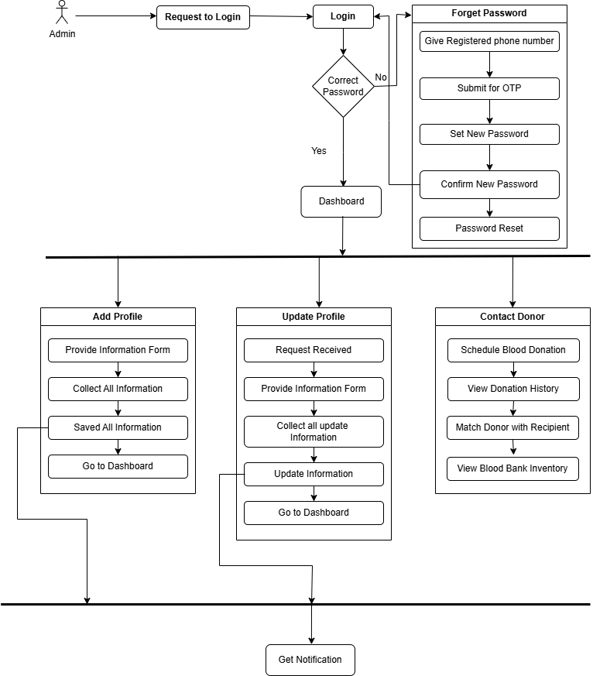

Figure-3: Block Diagram for System Administrator

# **Software Requirement Specification**

## **SRS**

|  |  |
| --- | --- |
| **FR01** | **Registration** |
| **Description** | Before using the blood management system recipient and donor must be registered first. |
| **Stakeholder** | Donor, Recipient |

|  |  |
| --- | --- |
| **FR02** | **Login** |
| **Description** | Recipient and Donor must login before using the hotel management system |
| **Stakeholder** | Donor, Recipient, System admin |

|  |  |
| --- | --- |
| **FR03** | **Add Profile** |
| **Description** | Recipient and Donor add his/her info to the system |
| **Stakeholder** | Donor, Recipient |

|  |  |
| --- | --- |
| **FR04** | **Update Profile** |
| **Description** | Recipient and Donor update/verify his/her profile must be use NID card |
| **Stakeholder** | Donor, Recipient |

|  |  |
| --- | --- |
| **FR05** | **Searching Donor** |
| **Description** | Recipient searching his/her require blood group |
| **Stakeholder** | Recipient |

|  |  |
| --- | --- |
| **FR06** | **Select Area** |
| **Description** | Recipient search specified area |
| **Stakeholder** | Recipient |

|  |  |
| --- | --- |
| **FR08** | **Request Blood** |
| **Description** | When Recipient not found there require blood group then his/her request for blood to request blood |
| **Stakeholder** | Recipient |

|  |  |
| --- | --- |
| **FR07** | **Review Donor** |
| **Description** | Donor add here review |
| **Stakeholder** | Donor |

|  |  |
| --- | --- |
| **FR09** | **Forget Password** |
| **Description** | If any user forgets their password then they can easily recover his or her password. |
| **Stakeholder** | Donor, Recipient, System admin |

|  |  |
| --- | --- |
| **FR10** | **Logout** |
| **Description** | Users can log out of this system by using this option. The login will be saved if the user wants to save their account. |
| **Stakeholder** | Donor, Recipient, System admin |

## **Use Case**

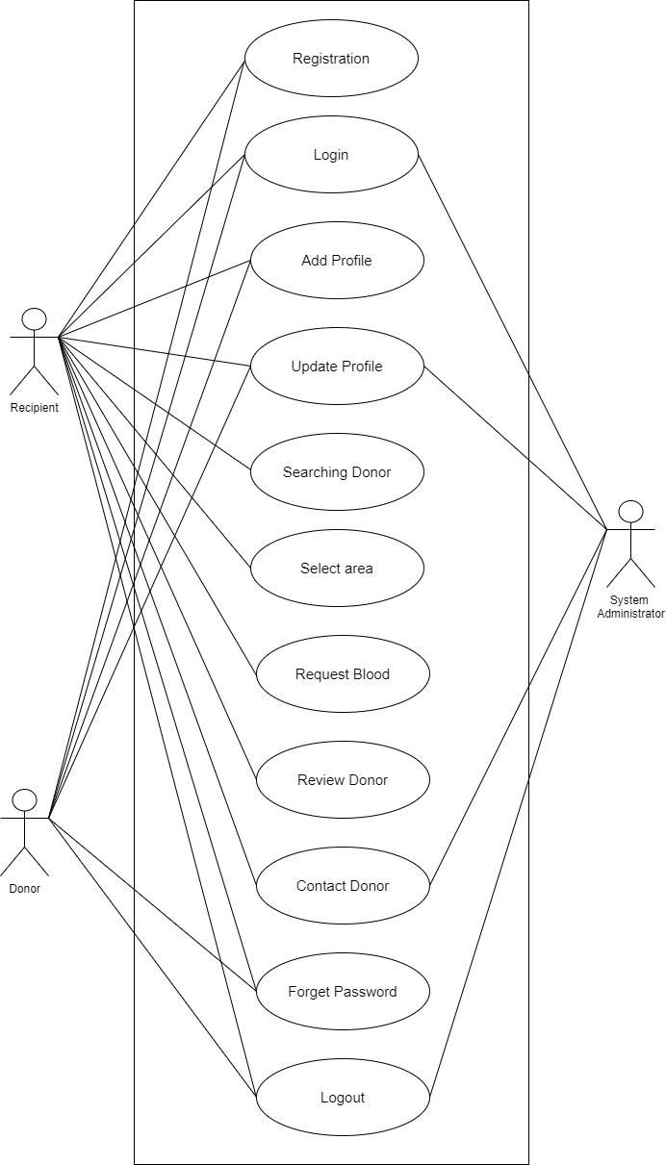

Figure-4: User Case Diagram for Blood Donation Management System

## **User Case Description**

### **Case Description-01: Registration**

|  |  |
| --- | --- |
| Use Case | Registration |
| Goal | Users can register to sign in to the system. |
| Precondition | Users must install the Hotel Management app for registration. |
| Success End Condition | Notification: !!!Successfully Registered!!! |
| Failed End Condition | Notification: “Submission Not Submitted” |
| Primary Actors:  Secondary Actors: | Donor, Recipient |
| Trigger | User will request a registration form to fill up |
| Description / Main Success Scenario | |  |  | | --- | --- | | 1 | Press “Registration” Button | | 2 | Provide registration form | | 3 | Enter Information | | 4 | Press “Submit” Button. | | 5 | Information saved | | 6 | The system saves the details and shows them !!!Successfully Registered!!! Notify | |
| Alternative Flows | |  |  | | --- | --- | | 1.1 | System Error | |  | 1.1.a. Try again !! | | 2.1 | System Doesn't work. | |  | 2.1.a. Try again later. | | 4.1 | The user Did not fill up the details! | |  | 4.1.a. Checked By the system & Notify by “Please! Fill Up the Box”. | | 5.1 | 5.1 The system did not respond | |  | 5.1.a. Show Error Message. | | 6.1 | The system Doesn’t save the details. | |  | 6.1.a. Notification: “Details did not Save” | |
| Quality Requirements | The user Will fill up all the details in 30 minutes. |

### 

### **Case Description-02: Login**

|  |  |
| --- | --- |
| Use Case | Login |
| Goal | Users can enter the system by the login. |
| Precondition | Users must have to be registered First. |
| Success End Condition | Notification: !!!Successfully login!!! |
| Failed End Condition | Notification: “Submission Not Submitted” |
| Primary Actors:  Secondary Actors: | Donor, Recipient  System Administrator |
| Trigger | The user will request a login to enter the system |
| Description / Main Success Scenario | |  |  | | --- | --- | | 1 | Press “Login” Button | | 2 | Provide Login form | | 3 | Enter user id and password | | 4 | Press “Login” Button. | | 5 | Verified and login | | 6 | The system saves the details and shows them !!!Successfully Login!!! Notify | |
| Alternative Flows | |  |  | | --- | --- | | 1.1 | System Error | |  | 1.1.a. Try again !! | | 2.1 | Server Not Found | |  | 2.1.a. Try again later. | | 4.1 | The system Did not respond. | |  | 4.1.a. Show error message. | | 5.1 | Information Error!! | |  | 5.1.a. Notification: “Enter the right User ID and Password.” | |
| Quality Requirements | The user Will fill up all the details in 10 minutes. |

### 

### **Case Description-03: Add Profile**

|  |  |
| --- | --- |
| Use Case | Add Profile |
| Goal | Adding the required information to create an account. |
| Precondition | The user must log in to the system. |
| Success End Condition | Notification: “Added Info Successfully” |
| Failed End Condition | Notifications: “Submission Not Submitted” |
| Primary Actors:  Secondary Actors: | Donor, Recipient  System Administrator |
| Trigger | Users will request to add their profile information in the profile info. |
| Description / Main Success Scenario | |  |  | | --- | --- | | 1 | Visit Dashboard | | 2 | Press “Added Profile Info” | | 3 | Provide information field | | 4 | Filled up information | | 5 | User press “Submit” button | | 6 | Profile info saved | | 7 | Successfully adding profile | |
| Alternative Flows | |  |  | | --- | --- | | 2.1 | System Error | |  | 2.1.a. Try again !! | | 3.1 | Not responding | |  | 3.1.a. Try again later. | | 4.1 | Check empty field. | |  | 4.1.a. Field up required information | | 5.1 | Info not saved | |  | 5.1.a Notification: “Info Not saved” | |
| Quality Requirements | Users have 30 minutes to fill up |

### 

### **Case Description-04: Update Profile**

|  |  |  |  |  |
| --- | --- | --- | --- | --- |
| Use Case | Update Profile | | | |
| Goal | Users update their profile info if they need any changes on the update | | | |
| Precondition | Must visit profile info | | | |
| Success End Condition | Notification “Profile Info Updated” | | | |
| Failed End Condition | Notification “Update Profile Failed” | | | |
| Primary Actors:  Secondary Actors: | Customer, Manager  Admin | | | |
| Trigger | Users will request to update their profiles. | | | |
| Description / Main Success  Scenario |  | | | |
|  | 1. | Visit Dashboard |  |
| 2. | Press “Update Profile” |  |
| 3. | Provide information field |  |
| 4. | Filled update information |  |
| 5. | User press “Submit” button |  |
| 6. | Profile information updated. |  |
| Alternative Flows |  | | | |
|  | 2.1 | System Error |  |
|  | 2.1.a Try again |  |
| 3.1 | Not responding |  |
|  | 3.1.a Try later |  |
| 5.1 | Information not updated |  |
|  | 5.1.a Notification: “Information Not Updated” |  |
| Quality Requirements | Users will get 15 mins to fill up | | | |

### 

### **Case Description-05: Searching Donor**

|  |  |  |  |  |
| --- | --- | --- | --- | --- |
| Use Case | Searching Donor | | | |
| Goal | Users can search donor to get their desired blood | | | |
| Precondition | Must be a verified User | | | |
| Success End Condition | Notification: “Donor Found.” | | | |
| Failed End Condition | Notification "No Donor Found." Or “Search Again” | | | |
| Primary Actors:  Secondary Actors: | User (Recipient)  Admin | | | |
| Trigger | User initiates a request to search for a blood donor. | | | |
| Description / Main Success  Scenario |  | | | |
|  | 1. | Visit Dashboard |  |
| 2. | Press “Search Donor” button. |  |
| 3. | Provide information field (blood type, location, etc.). |  |
| 4. | System shows matching donor profiles. |  |
| 5. | User views the list of available donors. |  |
| 6. | User selects a donor and presses “Contact Donor.” |  |
| Alternative Flows |  | | | |
|  | 2.1 | System Error |  |
|  | 2.1.a "System Error" message and tries again later. |  |
| 3.1 | No Donor Found |  |
|  | 3.1.a Modify the search information’s. |  |
| 5.1 | Donor Not Available |  |
|  | 5.1.a Notification “Donor Unavailable” and try another donor or perform a new search. |  |
| Quality Requirements | Users will get 15 mins to search the required blood | | | |

### 

### **Case Description-06: Select Area**

|  |  |
| --- | --- |
| Use Case | Select Area |
| Goal | Recipient can Search donor area wise for easily manage there require blood group. |
| Precondition | Must be logged in this system and NID verify profile |
| Success End Condition | View search results |
| Failed End Condition | Not result found |
| Primary Actors:  Secondary Actors: | Recipient |
| Trigger | Users will request to make a search for require blood |
| Description / Main Success Scenario | |  |  | | --- | --- | | 1 | Visit Dashboard | | 2 | Select “Searching field’ | | 3 | Fill up require area | | 4 | Enter search button | | 5 | Area matched | | 6 | View result | | 7 | Search successful | |
| Alternative Flows | |  |  | | --- | --- | | 1.1 | Server Down | |  | 1.1.a. Try again later | | 2.1 | System doesn’t respond | |  | 2.1.a. Try again later. | | 3.1 | No result match | |  | 4.1.a add report | | 4.1 | System Error | |  | 4.1.a. Try again | |
| Quality Requirements | Users will get 05 mines to fill up |

### 

### **Case Description-07: Request Blood**

|  |  |
| --- | --- |
| Use Case | Request Blood |
| Goal | Users can request for blood from the System. |
| Precondition | Users must Search a Group of blood, from search option. |
| Success End Condition | Notification: !!!This group of blood are available!!! |
| Failed End Condition | Notification: “Not Available at this moment” |
| Primary Actors:  Secondary Actors: | Customer |
| Trigger | User will request for blood. |
| Description / Main Success | 1. Press “Search” Button 2. Write blood group name. 3. Press “Enter” Button. 4. Information saved 5. This Blood available. |

|  |  |  |  |  |  |  |  |  |  |  |  |
| --- | --- | --- | --- | --- | --- | --- | --- | --- | --- | --- | --- |
| Alternative Flows | |  |  | | --- | --- | | 1.1 | Server Down | |  | 1.1 Try again | | 2.1 | Not Responding | |  | 2.1 | |  |  | |
| Quality Requirement | Users will get 10 mints for search. |

### 

### **Case Description-08: Review Donor**

|  |  |
| --- | --- |
| Use Case | Request Blood |
| Goal | Users can request for blood from the System. |
| Precondition | Users must Search a Group of blood, from search option. |
| Success End Condition | Notification: !!!This group of blood are available!!! |
| Failed End Condition | Notification: “Not Available at this moment” |
| Primary Actors:  Secondary Actors: | Customer |
| Trigger | User will request for blood. |
| Description / Main Success | 1. Press “Search” Button 2. Write blood group name. 3. Press “Enter” Button. 4. Information saved 5. This Blood available. |

|  |  |  |  |  |  |  |  |  |  |  |  |
| --- | --- | --- | --- | --- | --- | --- | --- | --- | --- | --- | --- |
| Alternative Flows | |  |  | | --- | --- | | 1.1 | Server Down | |  | 1.1 Try again | | 2.1 | Not Responding | |  | 2.1 | |  |  | |
| Quality Requirement | Users will get 10 mints for search. |

### 

### **Case Description-09: Contact Donor**

|  |  |
| --- | --- |
| Use Case | Contact Donor |
| Goal | Users can Contact to donor for blood from the System. |
| Precondition | Users must go to Contact option. |
| Success End Condition | Notification: !!!Your Contact information is available here!!! |
| Failed End Condition | Notification: “Not Available your contact information” |
| Primary Actors:  Secondary Actors: | Customer |
| Trigger | User will get contact information of donor. |
| Description / Main Success | 1. Press “Contact” Button 2. Search donor name or blood group. 3. Press “Enter” Button. 4. Information saved 5. Here is the donor information. |

|  |  |  |  |  |  |  |  |  |  |  |  |
| --- | --- | --- | --- | --- | --- | --- | --- | --- | --- | --- | --- |
| Alternative Flows | |  |  | | --- | --- | | 1.1 | Server Down | |  | 1.1 Try again | | 2.1 | Not Responding | |  | 2.1 report for this | |  |  | |
| Quality Requirement | Users will get 10 mints for found information of a donor. |

### 

### **Case Description-10: Forget Password**

|  |  |
| --- | --- |
| Use Case | Forget Password |
| Goal | Users can restore forgotten passwords. |
| Precondition | The user must log in to the system. |
| Success End Condition | Notification: “Password Restored Successfully”. |
| Failed End Condition | Notification:“ Password Restored Failed.” |
| Primary Actors:  Secondary Actors: | Donor, Recipient |
| Trigger | The user will request to Restore the pin. |
| Description / Main Success Scenario | |  |  | | --- | --- | | 1 | Log in to the system. | | 2 | Select the “Forget Password” Option. | | 3 | Enter the registered number | | 4 | Press the “Send Verification Code” Button. | | 5 | Enter the verification code | | 6 | Set new password | | 7 | Press “Save & Apply”. | | 8 | Password Forget successful | |
| Alternative Flows | |  |  | | --- | --- | | 1.1 | Server Down | |  | 1.1.a. Try again later | | 2.1 | Not Responding | |  | 2.1.a Reload | | 3.1 | Wrong phone number | |  | 3.1.a Notification: Choose the Valid Phone Number. | | 5.1 | Wrong OTP Code | |  | 5.1.a Notification: Choose the Valid OTP Code. | | 6.1 | System Error | |  | 6.1.a. Try again | |
| Quality Requirements | Users will get 30 mines to fill up |

### 

### **Case Description-11: Logout**

|  |  |
| --- | --- |
| Use Case | Logout |
| Goal | Users can Log Out from the system. |
| Precondition | The user must log in to the system. |
| Success End Condition | Notification: “Logout Successful”. |
| Failed End Condition | Notification: “System Error”. |
| Primary Actors:  Secondary Actors: | Donor, Recipient  System Administrator |
| Trigger | The user will request a Logout |
| Description / Main Success Scenario | |  |  | | --- | --- | | 1 | Log in to the system. | | 2 | Select the “Logout” Option. | | 3 | Press the “Logout” Button. | | 4 | Logout successful | |
| Alternative Flows | |  |  | | --- | --- | | 1.1 | Server Down | |  | 1.1.a. Try again later | | 2.1 | Not Responding | |  | 2.1.a. Try again later.  2.1.b. Reload | |
| Quality Requirements | The user will Immediately Logout After hitting the Logout Button. |

# **System Design**

## **Data Flow Diagram**

### **Data Flow Diagram Level-0:**

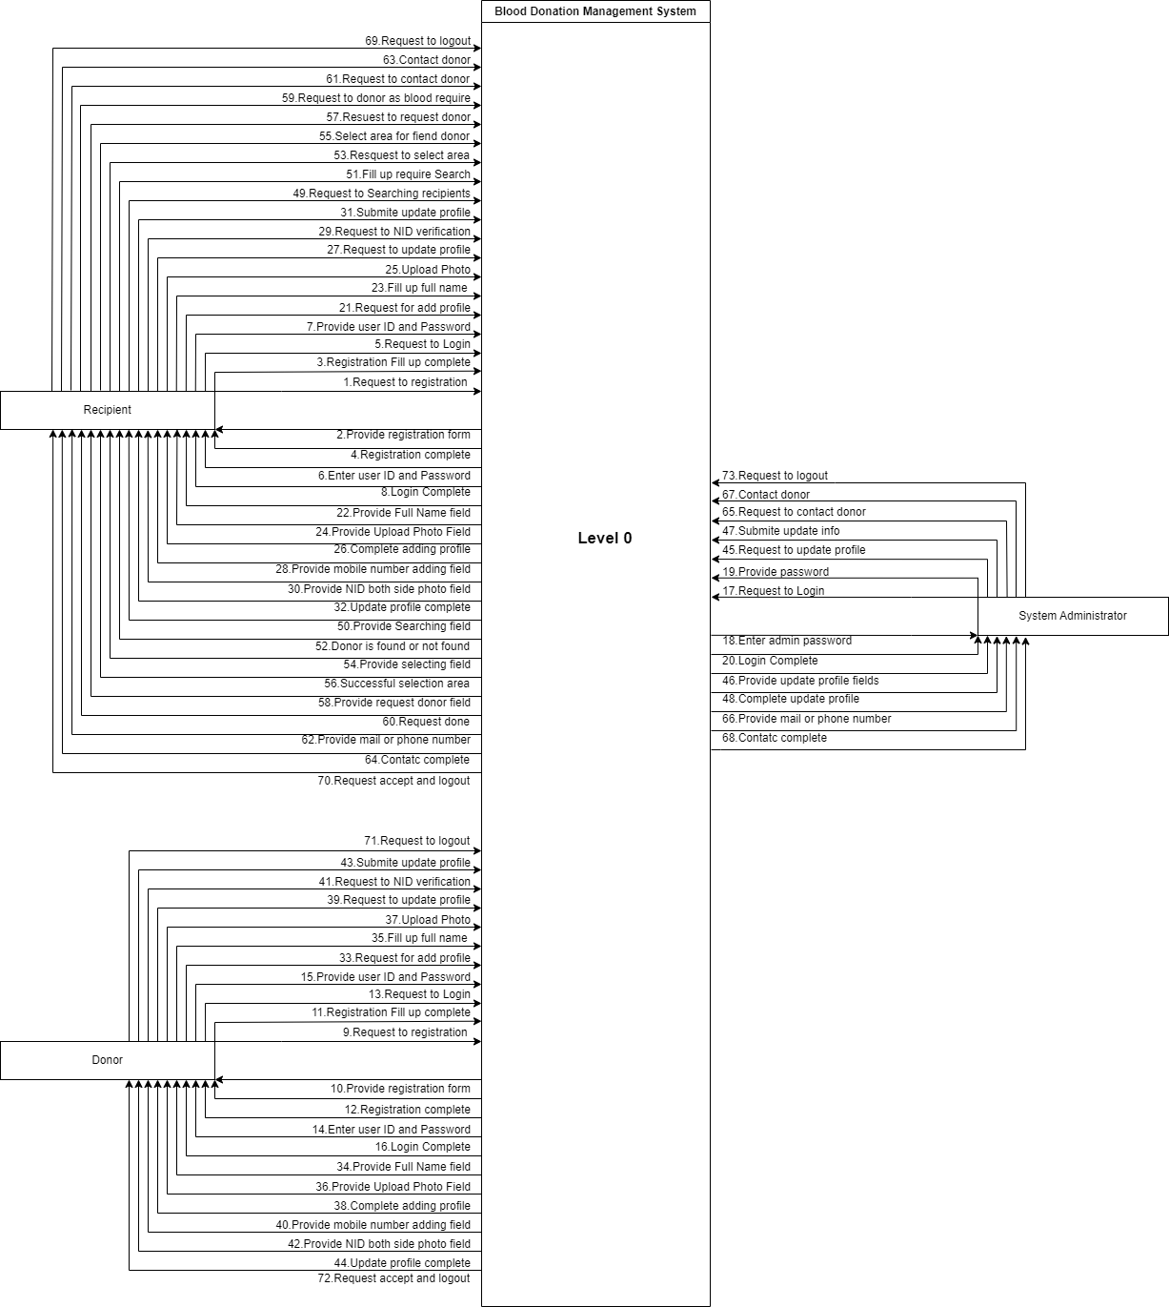

Figure-5: Data Flow Diagram Level 0

### **Data Flow Diagram Level-1:**

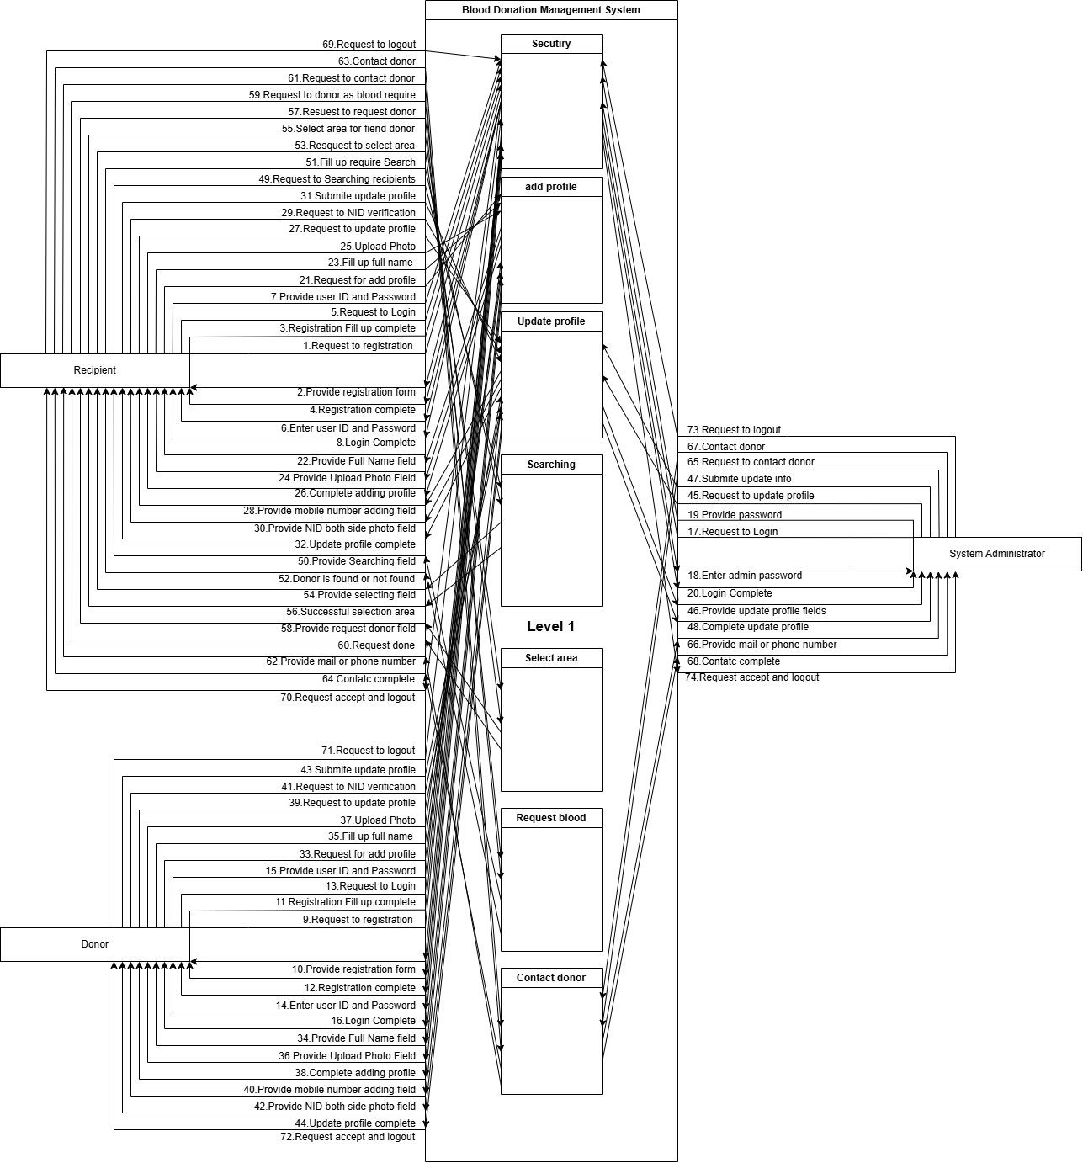

Figure-5: Data Flow Diagram Level 1

## **Activity Diagram**

### **Activity Diagram-1: Registration**

Figure-7: Activity Diagram for Registration

### **Activity Diagram-2: Login**

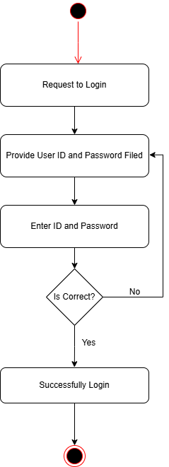

Figure-8: Activity Diagram for Login

### **Activity Diagram-3: Add Profile**

Figure-9: Activity Diagram for Add Profile

### **Activity Diagram-4: Update Profile**

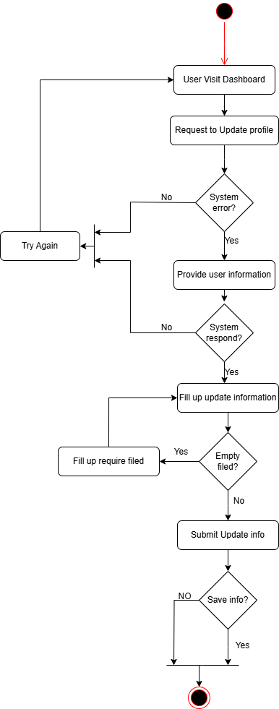

Figure-10: Activity Diagram for Update Profile

### **Activity Diagram-5: Searching Blood**

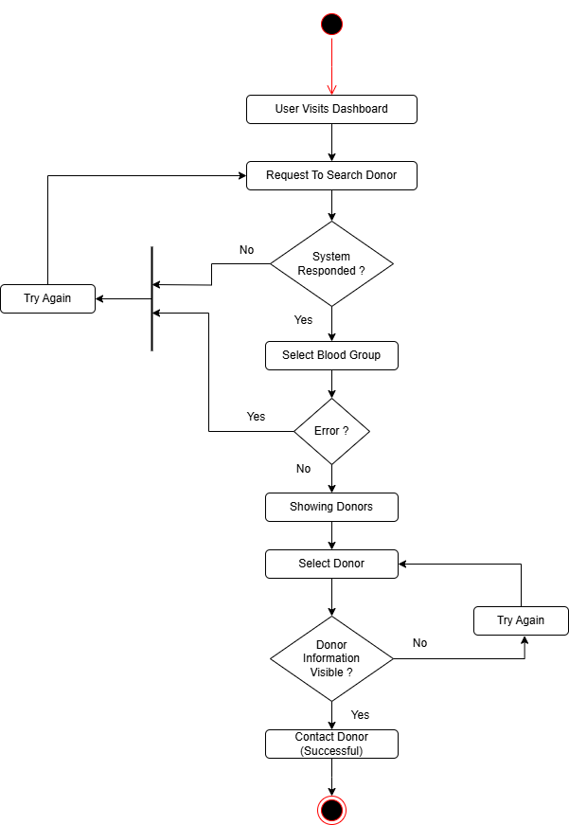

Figure-11: Activity Diagram for Searching Blood

### **Activity Diagram-6: Contact Donor**

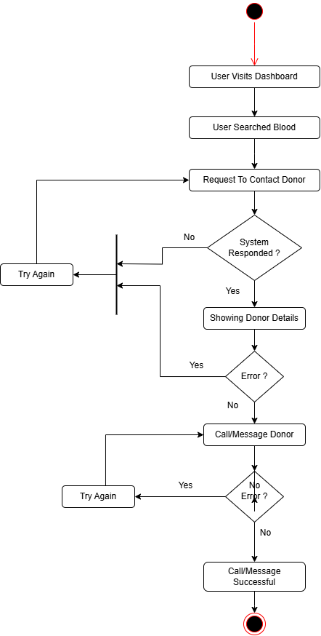

Figure-12: Activity Diagram for Contact Donor

### **Activity Diagram-7: Logout**

Figure-13: Activity Diagram for Logout

## **State Diagram**

### **State Diagram-1: Registration**

Figure- 14: State Diagram of Registration

### **State Diagram-2: Login**

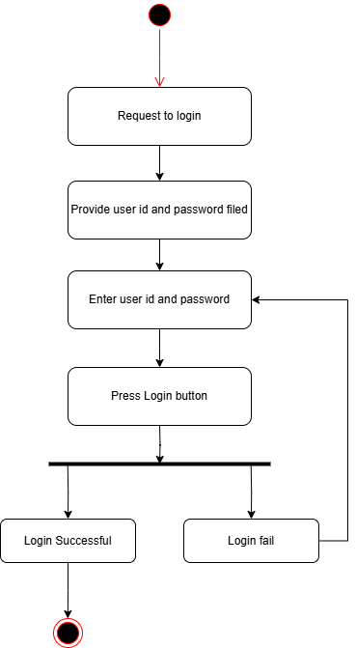

Figure- 15: State Diagram of Login

### **State Diagram-3: Add Profile**

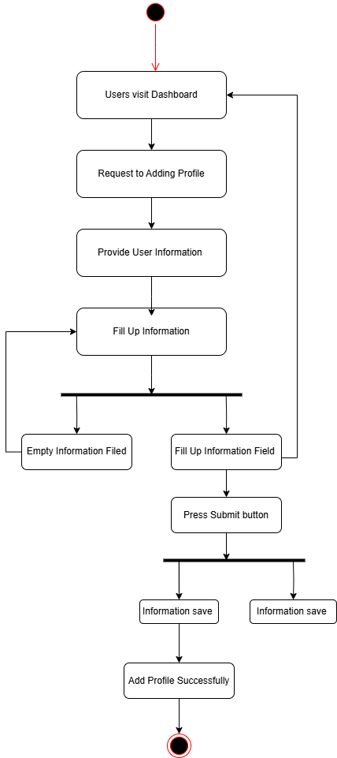

Figure- 16: State Diagram of Add profile

### **State Diagram-4: Update Profile**

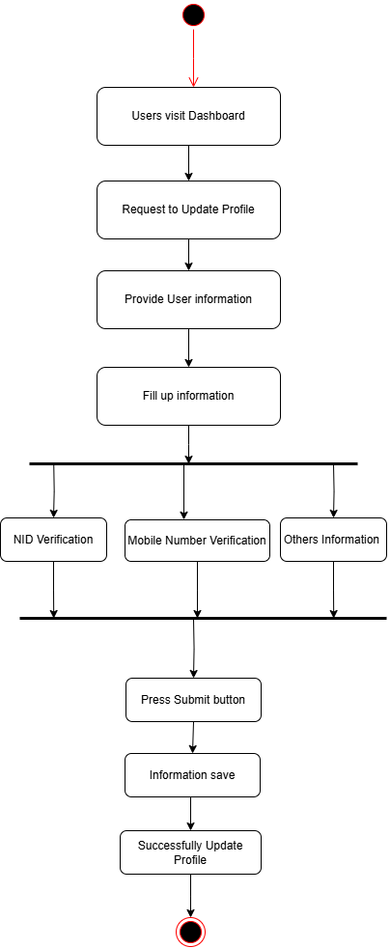

Figure- 17: State Diagram of Update profile

### **State Diagram-5: Searching Blood**

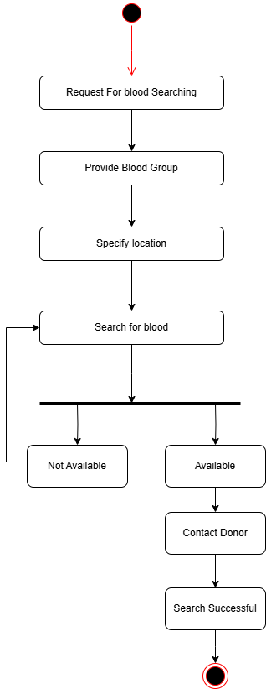

Figure- 18: State Diagram of Searching Blood

### **State Diagram-6: Contact Donor**

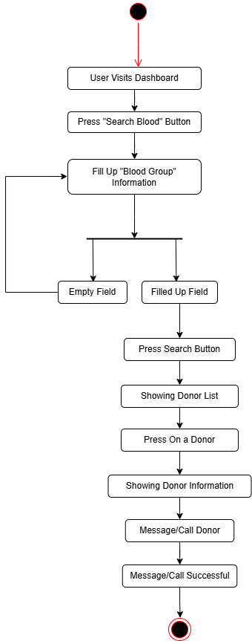

Figure- 19: State Diagram of Contact Donor

### **State Diagram-7: Logout**

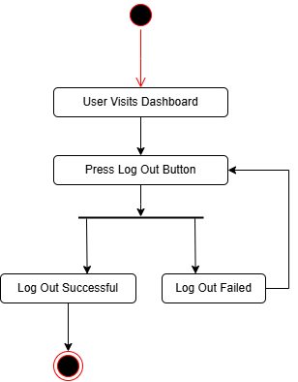

Figure- 20: State Diagram of Logout

## **Sequence Diagram**

### **Sequence Diagram-1: Registration**

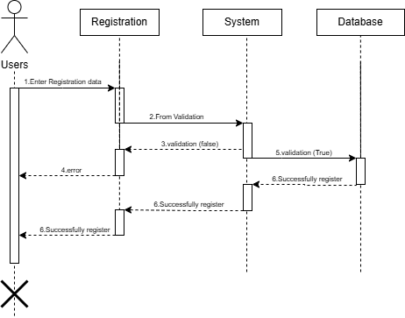

Figure-21: Sequence Diagram for Login

### **Sequence Diagram-2: Login**

Figure-22: Sequence Diagram for Registration

### **Sequence Diagram-3: Add Profile**

Figure-23: Sequence Diagram for Add Profile

### **Sequence Diagram-4: Update Profile**

Figure-24: Sequence Diagram for Update Profile

### **Sequence Diagram-5: Searching Donor**

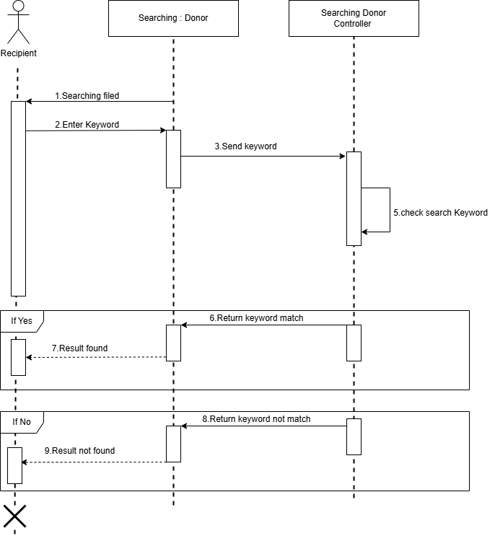

Figure-25: Sequence Diagram for Searching Donor

### **Sequence Diagram-6: Contact Donor**

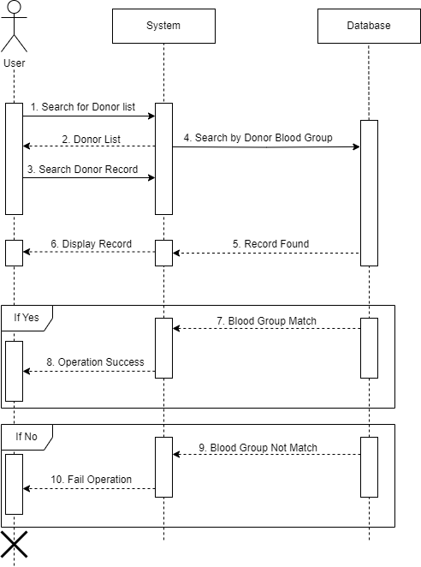

Figure-26: Sequence Diagram for Contact Donor

### **Sequence Diagram-7: Logout**

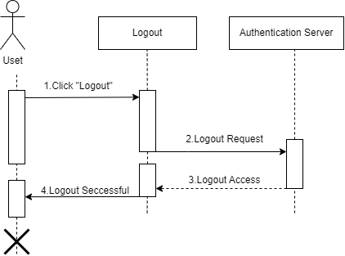

Figure-27: Sequence Diagram for Logout

# **Class Diagram**

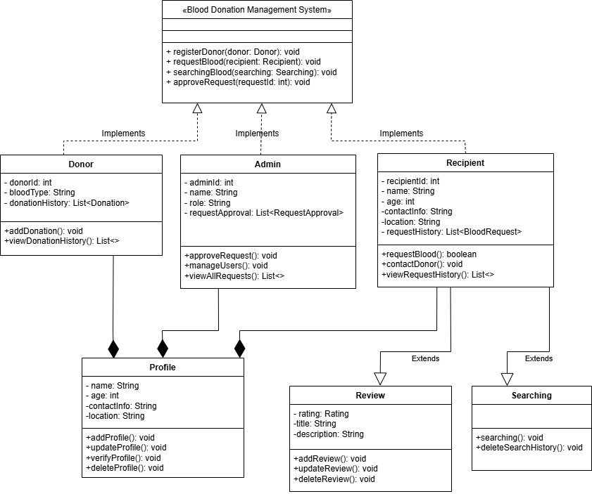

Figure-28: Class Diagram for Blood Donation Management System

# **ER Diagram**

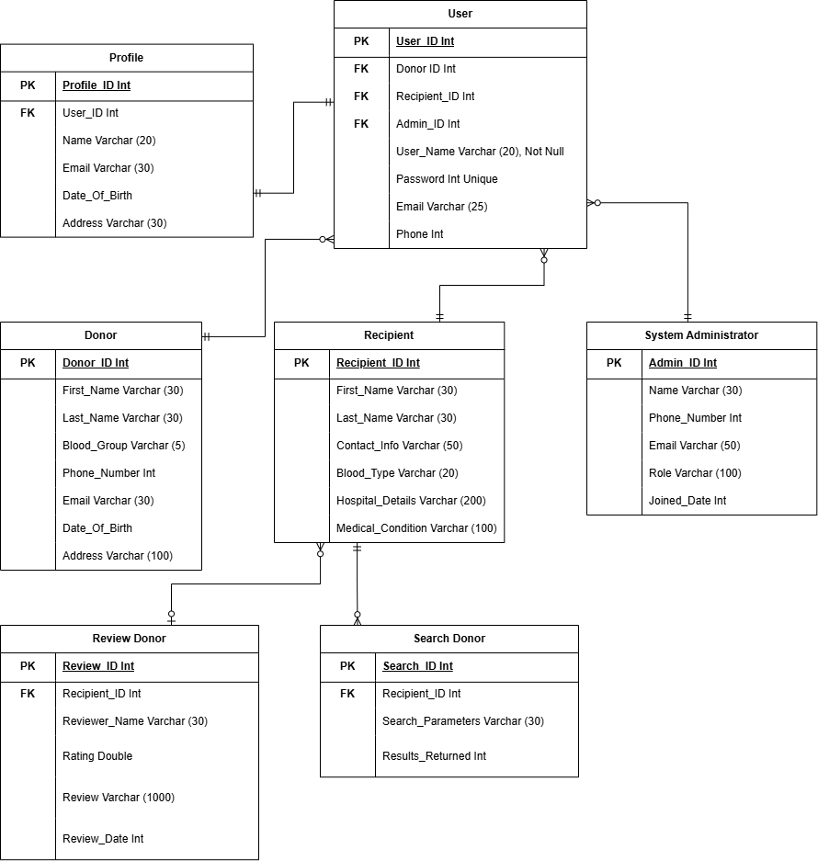

Figure-29: ER Diagram for Blood Donation Management System